# Phase 3 Evaluation: Fallahi Dataset

Below are 5 biological findings for explanation from Fallahi-Sichani et al. (2015)[1]. We ask that you produce mechanistic explanations for the first finding and at least one of the other four biological findings. For each finding, we have provided a figure. Data for use with this evaluation are available on MITRE’s Big Mechanism Handshake page[2]. The first submission on this data set will be due on September 15th, 2017. There will be one additional iteration and submission using this data set due before the PI meeting.

Explanations of findings should be derived from one model per submission, with differences in parameterization for each cell line based on data about the cell line (mutations, gene expression, and other information). These differences may include turning off interactions, changes in interaction strengths, etc. If an interaction is present in any cell line, it should show up in the complete model.

Each submission should include:

* A summary of the methods used to generate the model.
* Files containing all interactions in your model and parameterizations that you make for each cell line. This data should be in machine-readable format. As before, all interactions in your model should be provided with provenance and evidence (PubMed ID and text in the case of machine reading, database identifiers if taken from public resources). For reading, include whether human curation or machine reading was performed.
* A table or tab-delimited file showing the model output for the findings and how they compare with the experimental results.
* For each perturbation/measurement pair, the pathway(s) in the model from the perturbation to the measured output that explain the observation.
* For each explanation about cell line differences, a brief summary of the differences between the model parameters (initial conditions, interaction “on/off states”, etc.) responsible for the findings.

The five findings involve:

* 6 cell lines
* 5 drugs
  + 4 RAF inhibitors (AZ628, PLX4720, SB590885, vemurafenib)
  + 1 MEK inhibitor (selumetinib)
* 7 different concentrations of drugs
* Measurements at 5 time points (1, 5, 10, 24, and 48 hours)
* Measurements of 4 different phosphorylated proteins and total c-Jun

**Findings to Explain**

|  |  |  |  |  |  |
| --- | --- | --- | --- | --- | --- |
|  | Finding ID | Cell lines | Drugs | Antibody Target | Finding |
| Required | 1 | C32, LOXIMVI, MMACSF, MZ7MEL, RVH421 | all | p-S6(S235/236) | We observe a dose-dependent decrease of p-S6(S235/236) across five cell lines and drugs. Feel free to use any or all of the time points in your explanation. |
| Choose at least one | 2 | LOXIMVI, RVH421 | all | pERK(T202/Y204) | We observe an increase in the abundance of pERK(T202/Y204) at low dosages across all drugs in the LOXIMVI cell line at 1 hour after treatment. In contrast, the cell line RVH421 shows a dose-dependent decrease in the abundance of pERK(T202/Y204) across the time course. |
| 3 | LOXIMVI | AZ628 | p-Histone H3(S10) | We observe a dose-dependent decrease of in the abundance of p-Histone H3(S10) in the cell line LOXIMVI in response to AZ628 but not in response to the other drugs. |
| 4 | WM115, C32 | all | p-AKT(S473) | During intermediate time points, we observe a decrease in the abundance of p-AKT(S473) in the cell line WM115 but not in the cell line C32. |
| 5 | RVH421, C32 | all | Total c-Jun | We observe a dose-dependent increase in total c-Jun in the cell line RVH421 but a dose-dependent decrease in total c-Jun in the cell line C32. |

# Finding 1

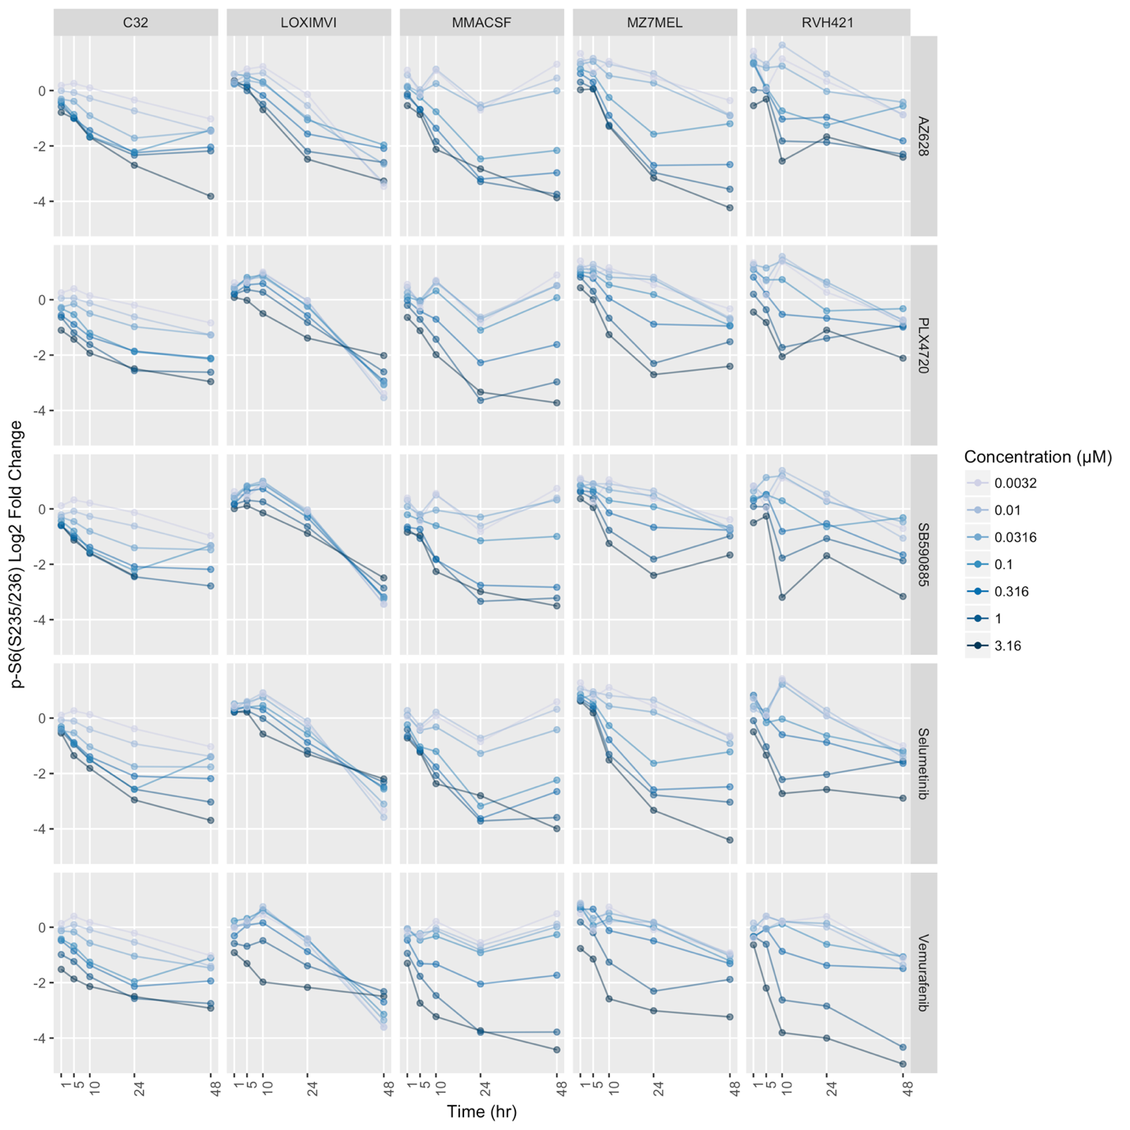

Each row in this figure corresponds to a drug (labels to the right of each row in gray boxes). Each column corresponds to a cell line (labels in gray boxes at the top of the plot). We observe a dose-dependent decrease of p-S6(S235/236) across five cell lines and drugs. Feel free to use any or all of the time points in your explanation.

# Finding 2

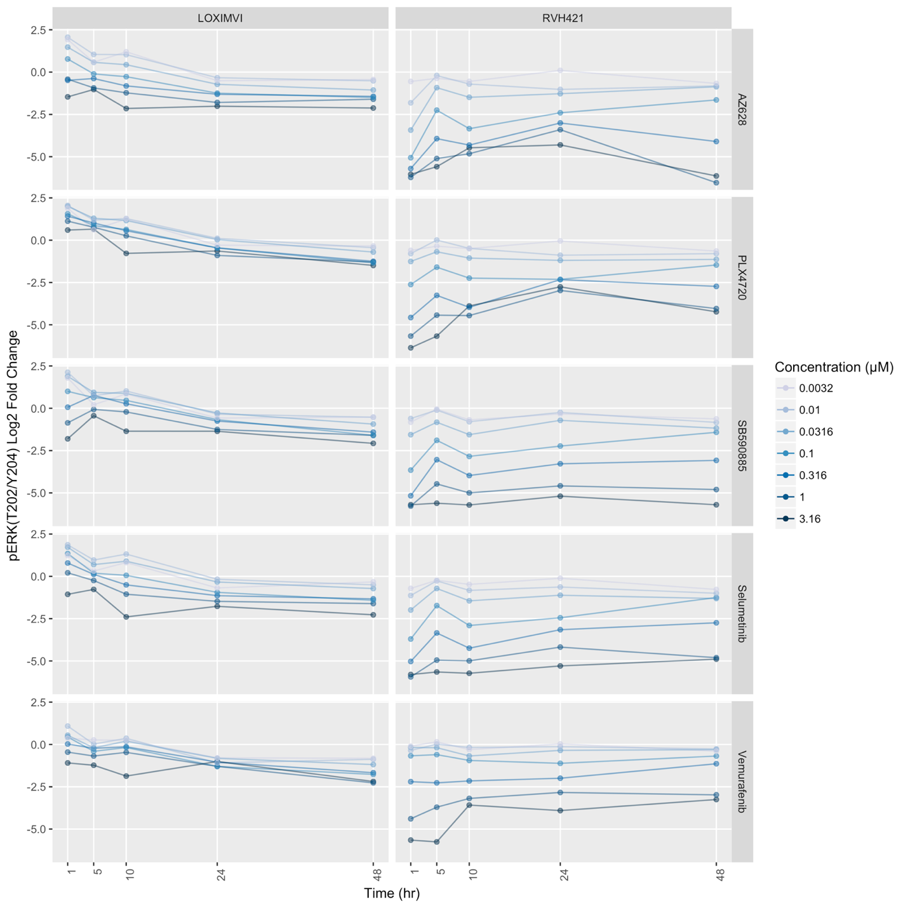

Each row in this figure corresponds to a drug (labels to the right of each row in gray boxes). Each column corresponds to a cell line (labels in gray boxes at the top of the plot). We observe an increase in the abundance of pERK(T202/Y204) at low dosages across all drugs in the LOXIMVI cell line at 1 hour after treatment. In contrast, the cell line RVH421 shows a dose-dependent decrease in the abundance of pERK(T202/Y204) across the time course.

# Finding 3

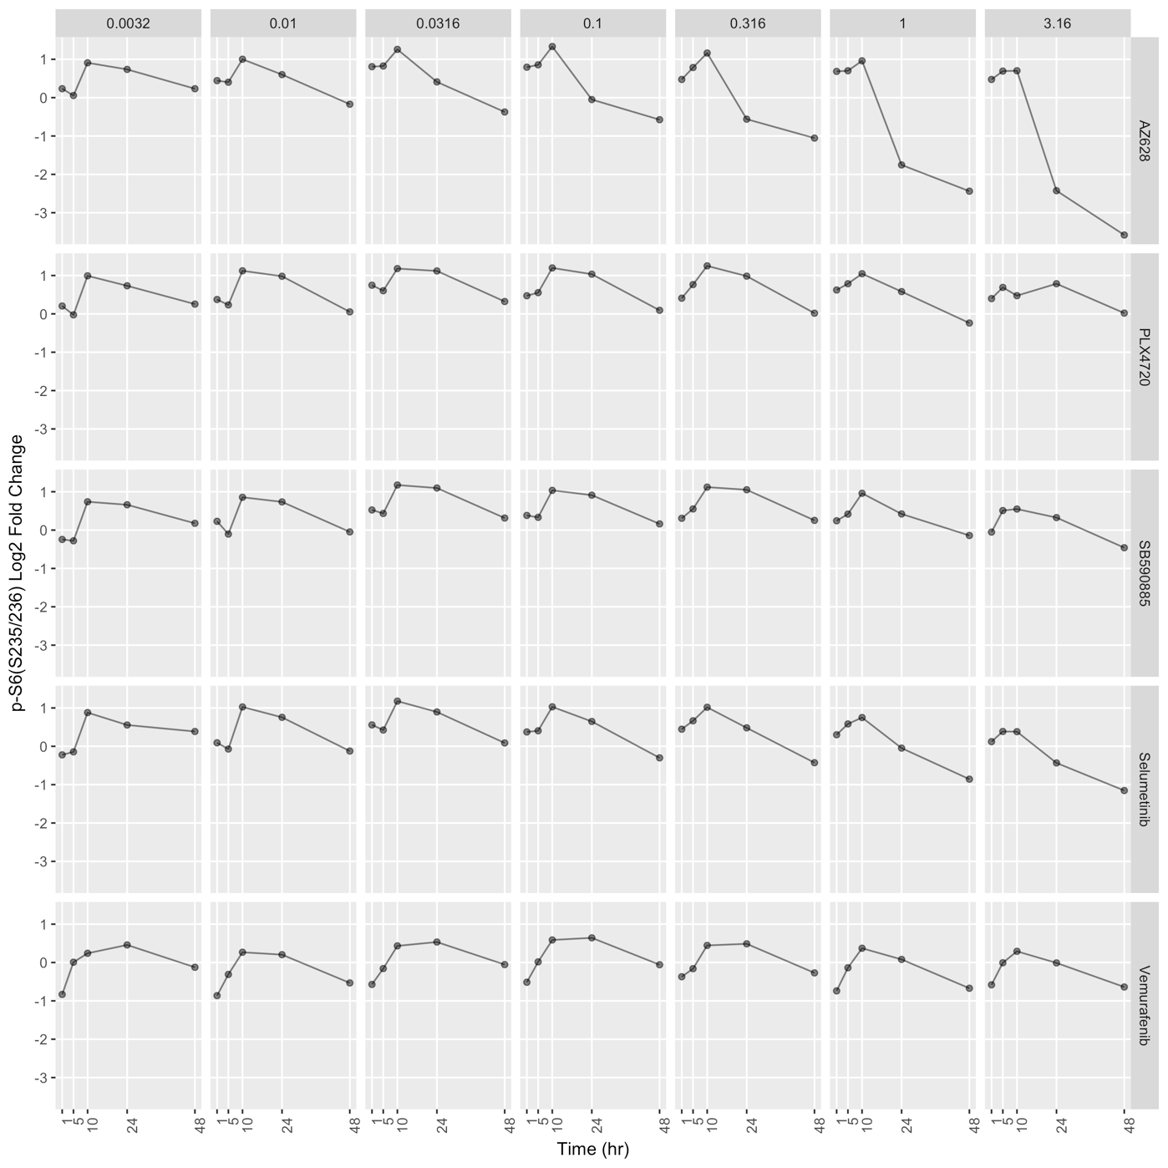

Each subplot in this figure corresponds to measurements in the cell line LOXIMVI. Each row in this figure corresponds to a drug (labels to the right of each row in gray boxes). Each column corresponds to a drug concentration in µM (labels in gray boxes at the top of the plot). We observe a dose-dependent decrease of in the abundance of p-Histone H3(S10) in the cell line LOXIMVI in response to AZ628 but not in response to the other drugs.

# Finding 4

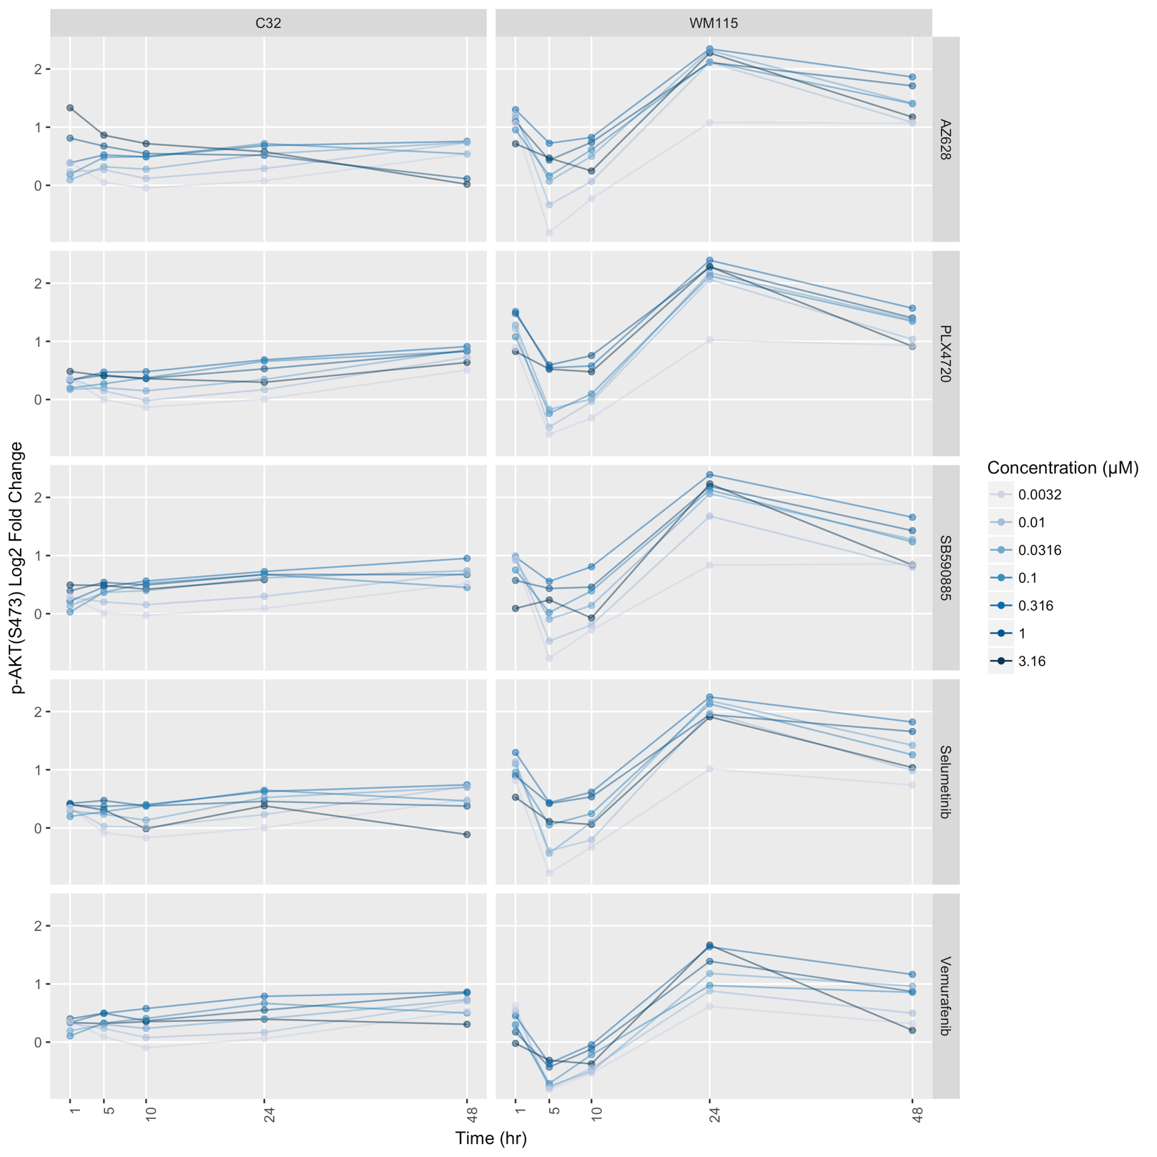

Each row in this figure corresponds to a drug (labels to the right of each row in gray boxes). Each column corresponds to a cell line (labels in gray boxes at the top of the plot). During intermediate time points, we observe a decrease in the abundance of p-AKT(S473) in the cell line WM115 but not in the cell line C32.

# Finding 5

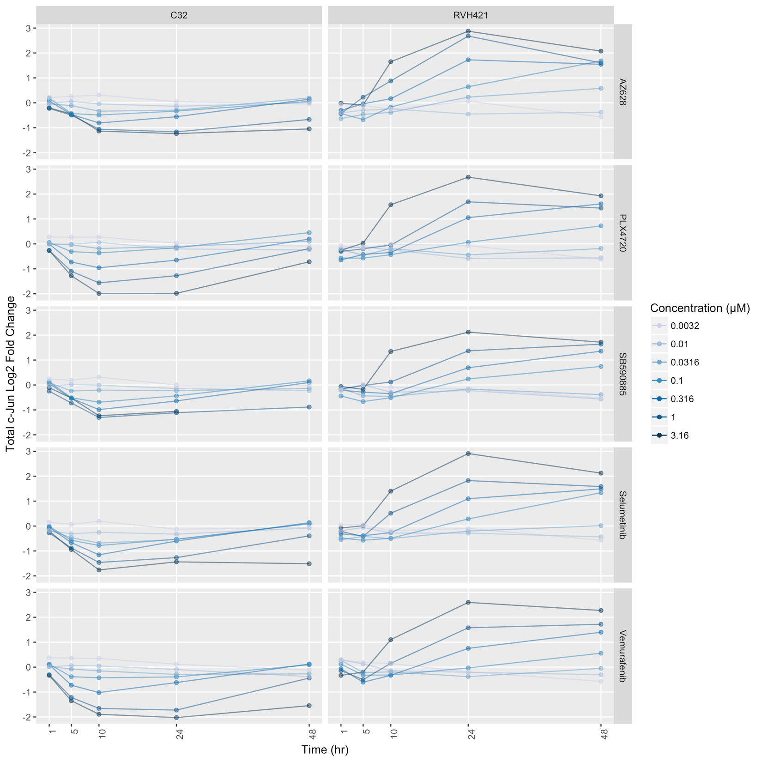

Each row in this figure corresponds to a drug (labels to the right of each row in gray boxes). Each column corresponds to a cell line (labels in gray boxes at the top of the plot). We observe a dose-dependent increase in total c-Jun in the cell line RVH421 but a dose-dependent decrease in total c-Jun in the cell line C32.

1. <https://www.ncbi.nlm.nih.gov/pubmed/25814555>
2. <https://handshake.mitre.org/groups/profile/15081483/big-mechanism-phase-iii-evaluation>